University of Computer Studies (Magway)
Project Report on
Asia Explorer System
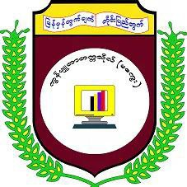

Submitted in Partial Fulfillment
for the Award of
Object Oriented Design and Development (CS-4223)
&
Advanced Database System (CS-4225)
Supervised By: Dr. Amy Aung
Daw Thet Su Hlaing
Presented by
Group: (2)
Ma Hay Mar Zaw UCSMG-22013
Ma Win Htet Htet Aung UCSMG-22021
Ma Ei Thazin Aung UCSMG-22034
Ma Hsu May Phoo Pan UCSMG-22037
Ma Su Mon Htwe UCSMG-22039
Ma May Chue Khin UCSMG-22050
Ma Nandar Aung UCSMG-22054
September, 2026

